CMPSC 412 – Lab-7 (25 points)
Binary Search Tree

Due date: 10/18/2022

Lab Exercises:
In continuation of Lab exercise 6.1.

Exercise-1:
In continuation of Lab exercise 6.1., Develop a Binary Search Tree (BST) which can perform the following functions:
- Insert a new student with unique PSU ID and student details using BST
- Find a student using PSU ID
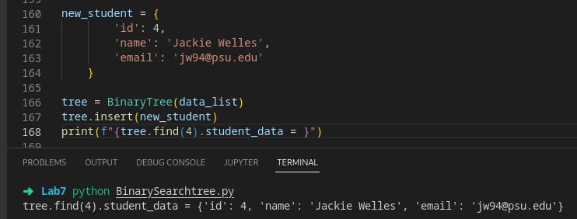

- Print each student with all details

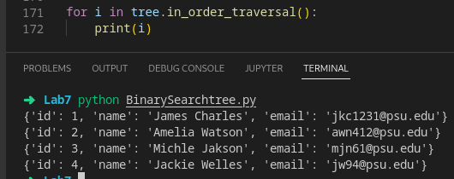

Hint: you can store the student’s details as a list or dictionary as a node in the BST.

Exercise-2: (not in continuation with Exercise-1)
- Write a function which takes a list of elements and builds a Binary search tree?

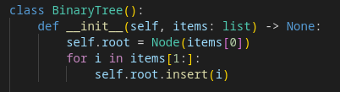

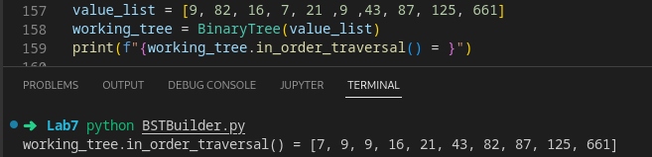

- Given a binary tree, check whether the given binary tree is a valid binary search tree (BST) or not.
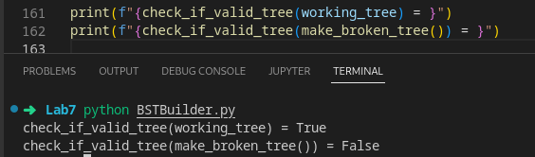

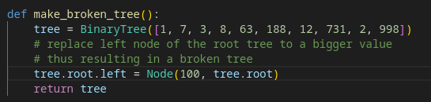

Note: create a tree with minimum 10 values and demonstrate all the functions. Attach the screenshots of the results.

